EXPT NO: 3 | IMPLEMENTATION OF CONVOLUTIONAL NEURAL NETWORKS (CNNs) FOR IMAGE CLASSIFICATION
DATE: 10/08/2026

PRE-LAB QUESTIONS (PROVIDE BRIEF ANSWERS TO THE FOLLOWING QUESTIONS)

1. What is a Convolutional Neural Network (CNN)?
A CNN is a deep learning model mainly used for processing images and visual data.
It automatically learns features such as edges, shapes, and patterns from images.
CNNs commonly use convolution, pooling, and fully connected layers.
They are widely used in image classification, detection, and recognition.

2. What are the functions of convolution and pooling layers in a CNN?
The convolution layer extracts important features from an image using filters or kernels.
The pooling layer reduces the size of feature maps while retaining important information.
Pooling also reduces computation and helps prevent overfitting.
Together, they help the CNN learn useful visual features efficiently.

3. Differentiate between image classification and object detection.
Image classification assigns a single or multiple labels to an entire image.
Object detection identifies objects and also determines their locations using bounding boxes.
For example, classification may say “cat,” while detection identifies “cat” and its position.
Object detection is therefore more detailed than image classification.

4. Why is image preprocessing important before training a CNN model?
Image preprocessing prepares images into a suitable format for CNN training.
It may include resizing, normalization, noise removal, and data augmentation.
It improves training speed, stability, and model performance.
It also helps the model learn useful features more effectively.

5. What are the advantages of using benchmark datasets such as CIFAR-10 or Kaggle image datasets?
Benchmark datasets provide standardized and well-organized data for training and testing models.
They make it easier to compare the performance of different CNN models.
They are useful for learning, experimentation, and evaluating model accuracy.
Kaggle datasets also provide a wide variety of real-world image data.

AIM
To design, implement, and evaluate a Convolutional Neural Network (CNN) for image classification using a benchmark image dataset.

SOFTWARE REQUIREMENTS
- Python
- TensorFlow/Keras or PyTorch
- Google Colab
- Matplotlib
- Kaggle Dataset (e.g., CIFAR-10, Cats vs Dogs, Intel Image Classification)

OBJECTIVES
Students will be able to:
- Understand the architecture of Convolutional Neural Networks.
- Implement a CNN model for image classification.
- Train and evaluate a CNN using a real-world image dataset.
- Visualize training and validation performance.
- Analyze the effectiveness of CNNs for image recognition tasks.

PROCEDURE
PART A: DATASET PREPARATION
- Perform the following tasks:
- Download an image dataset from Kaggle or use CIFAR-10.
- Load the dataset.
- Preprocess images by resizing and normalization.
- Split the dataset into training, validation, and testing sets.
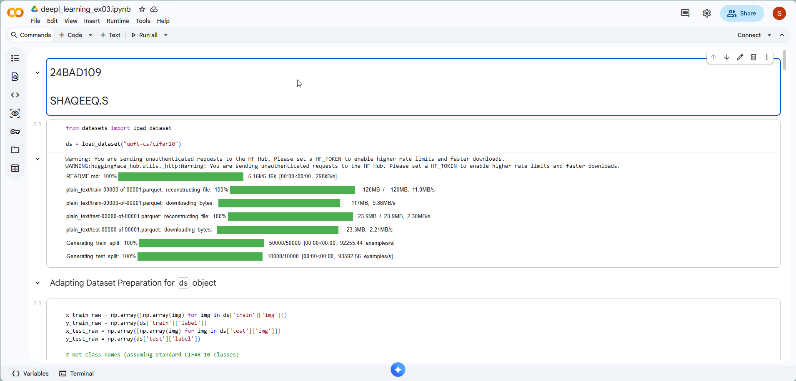
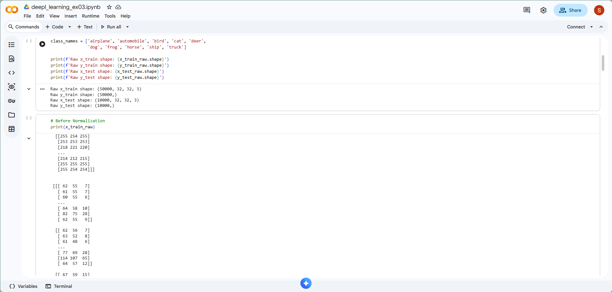
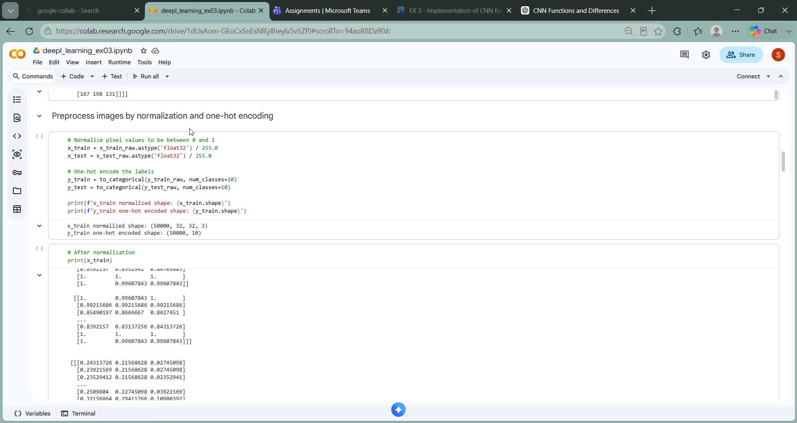
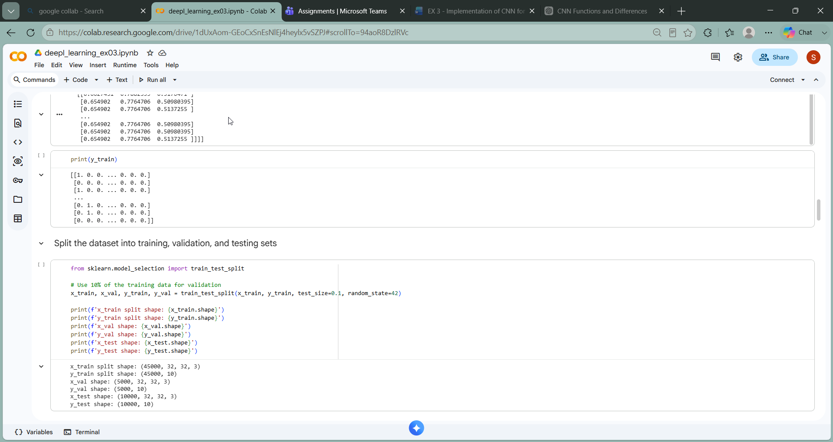

PART B: CNN MODEL IMPLEMENTATION
Build a CNN model consisting of:
- Convolution layers
- ReLU activation
- Max Pooling layers
- Fully Connected layers
- Softmax output layer

Compile the model using:
- Appropriate optimizer
- Cross-entropy loss function
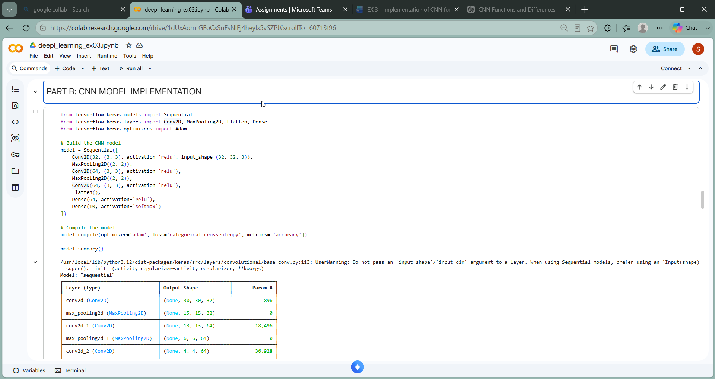

PART C: MODEL TRAINING AND EVALUATION
Train the CNN model.
Record:
- Training accuracy
- Validation accuracy
- Training loss
- Validation loss
- Testing accuracy
Plot:
- Accuracy vs Epoch
- Loss vs Epoch
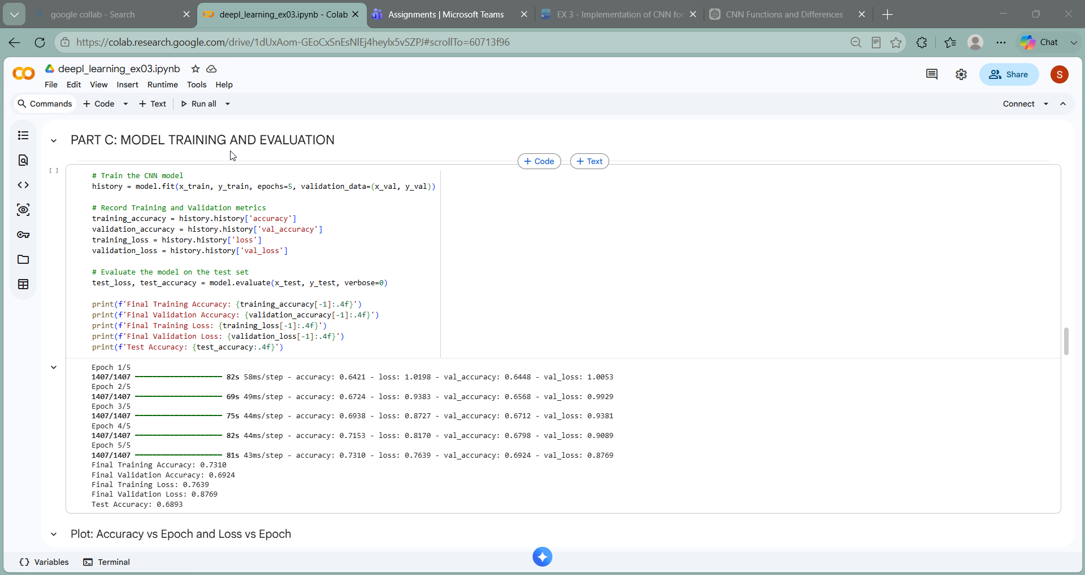
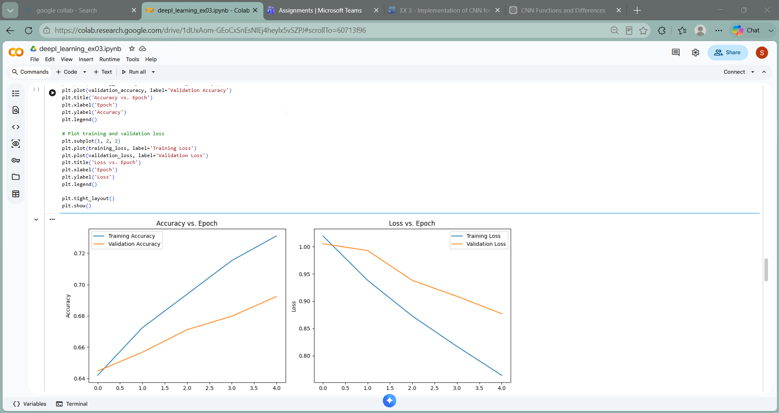

PART D: PERFORMANCE ANALYSIS
Analyze:
- Classification accuracy
- Confusion Matrix
- Sample predictions
- Misclassified images
Discuss the strengths and limitations of CNNs for image classification.

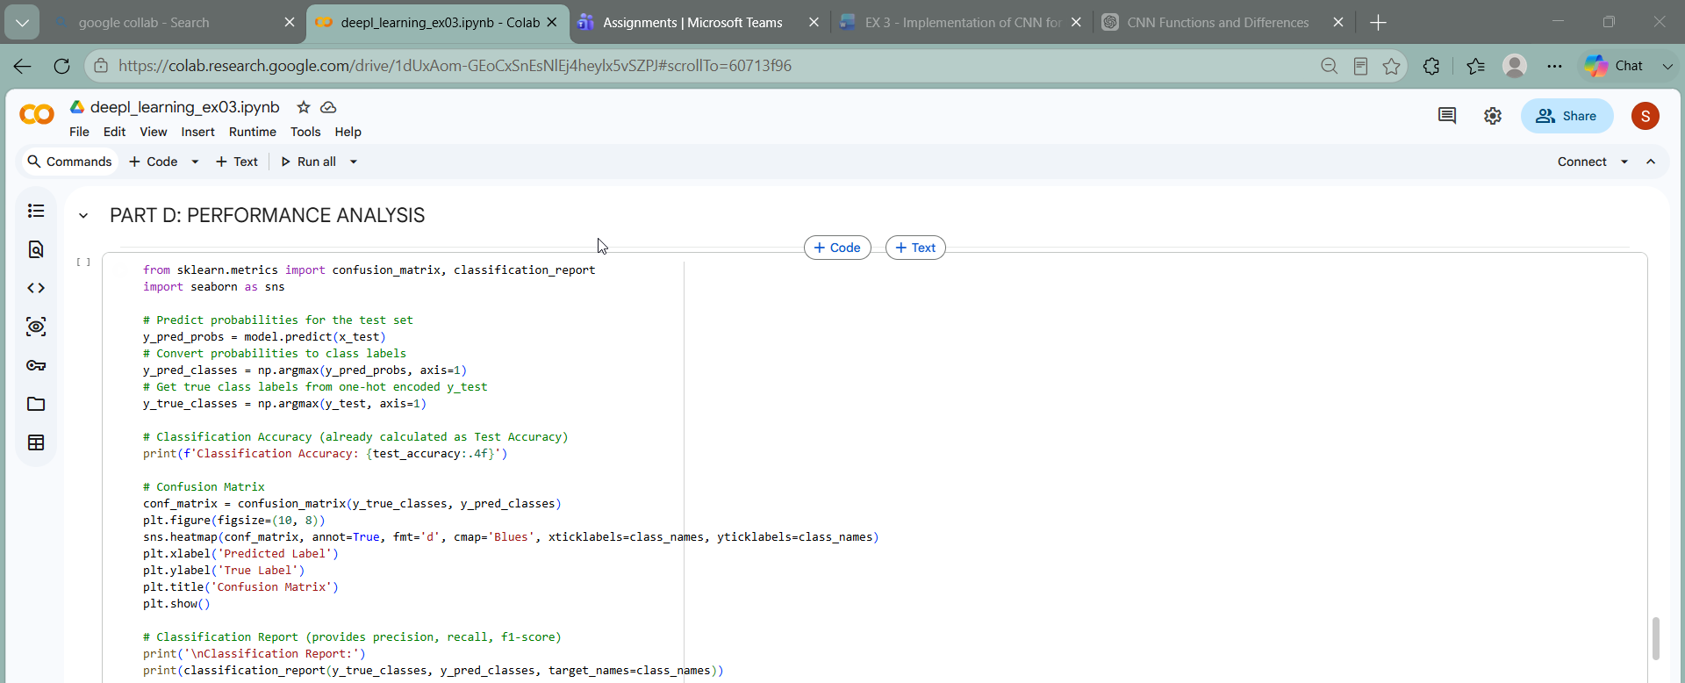
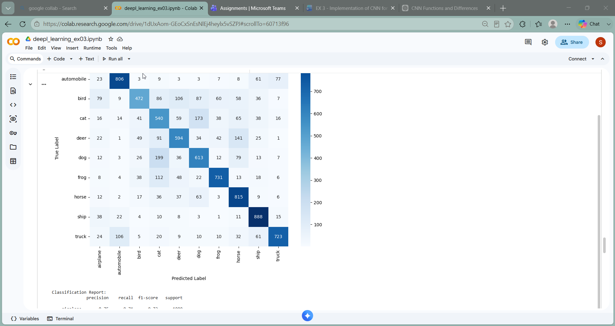
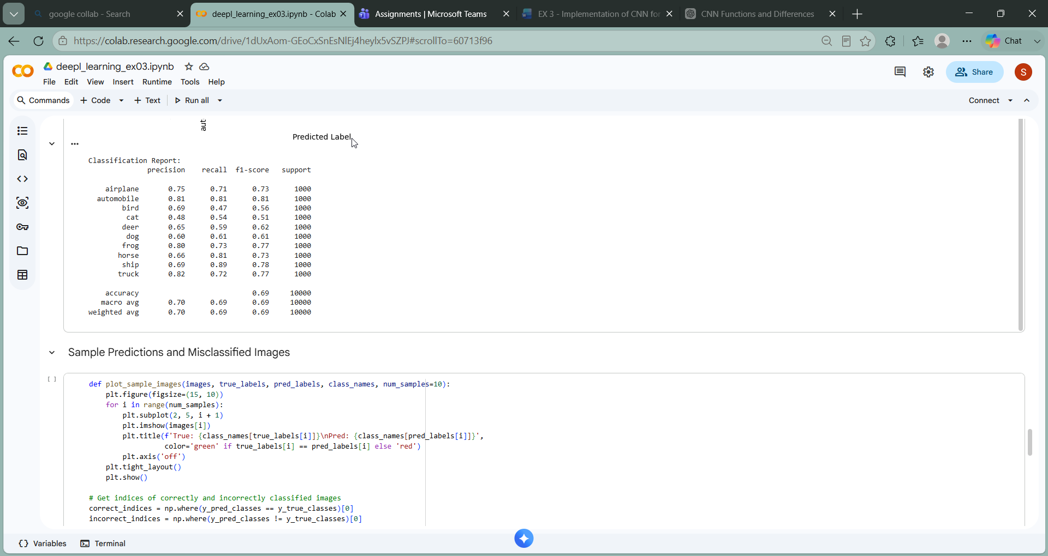
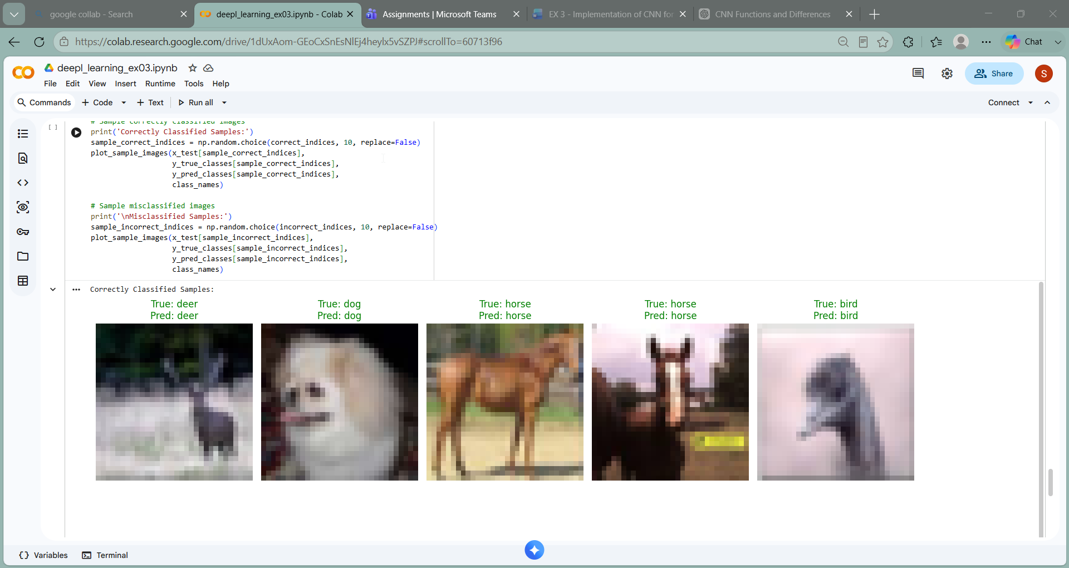

EXPECTED OUTCOME
Students will gain practical experience in designing, training, and evaluating CNN models for image classification and understand how CNN architecture influences classification performance.

POST-LAB QUESTIONS (PROVIDE BRIEF ANSWERS TO THE FOLLOWING QUESTIONS)

1. Why are convolution layers more effective than fully connected layers for image processing?
Convolution layers preserve the spatial structure of images and detect local features such as edges and textures.
They use shared filters, which greatly reduces the number of parameters.
Fully connected layers require many more parameters for image data.
Therefore, convolution layers are more efficient for image processing.

2. How does Max Pooling improve CNN performance?
Max Pooling reduces the spatial size of feature maps while retaining the most important features.
It decreases computation and the number of parameters in the network.
It also helps reduce overfitting and makes the model less sensitive to small changes in images.
Thus, it improves CNN efficiency and generalization.

3. Which hyperparameters significantly affected your CNN model performance?
Important hyperparameters include learning rate, batch size, number of epochs, filter size, and number of filters.
The learning rate strongly affects how quickly and effectively the model learns.
The number of filters and layers affects the model's ability to extract features.
Batch size and epochs also influence training stability and accuracy.

4. What challenges did you encounter while training the CNN model?
Common challenges include overfitting, slow training, low accuracy, and choosing suitable hyperparameters.
The model may perform well on training data but poorly on unseen data.
Limited computational resources can also increase training time.
These issues can be reduced using data augmentation, regularization, and hyperparameter tuning.

5. Suggest two improvements that can increase the classification accuracy of your CNN.
Data augmentation can increase the variety of training images and reduce overfitting.
Transfer learning using a pretrained model can provide better feature extraction.
Other techniques include hyperparameter tuning and adding suitable regularization.
These methods can improve the model's accuracy and generalization.

ASSESSMENT
Description | Max Marks | Marks Awarded
Pre Lab Exercise | 5
In Lab Exercise | 10
Post Lab Exercise | 5
Viva | 10
Total | 30
Faculty Signature

